 | Title: | PERSONAL EFFECTS |  | Policy # |  | MO.2.01
 | Division: | Forensic, Investigation |  | Page: |  | Page 1 of 2
Coroner Signature: |  | 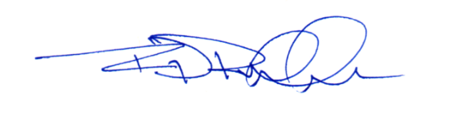 | NAME Reference: |  | C1i, C1j,F4e
Approved/Revised Date: |  | 02-20-2024 | IACME Reference: |  | A6k,B1q


POLICY:
To ensure that the secure, efficient, and timely collection and release of personal effects, including currency, is completed in accordance with statutory regulation, the mission of the Ada County Coroner’s Office (ACCO) and established standard operating procedures.

PROCEDURE:
- General
  - All personal effects located on a decedent or within a body bag, and transported to the ACCO, shall be photographed, inventoried, and notated within the ACCO case management system by the Forensic Division.
  - All personal effects that accompany the decedent to the ACCO, outside of the body bag; shall be photographed, inventoried, notated within the ACCO case management system by the Forensic Division, and placed with the decedent once inventory is complete.
- Inventory
  - All personal effects located on the decedent at the time of postmortem examination shall be documented, removed from the body, placed within a labeled container, and remain with decedent pending release.
  - In the event that the Forensic Division is unable to remove an item from the decedent’s person, the item shall be photographed, inventoried, and notated in the ACCO case management system as “left on body.”
    - The receiving party shall be notified at time of release.
- Release
  - One or more personal effects may be released to the investigating law enforcement agency when requested, and as approved by the forensic pathologist.
  - As approved by ACCO administration, personal effects may be released directly to next-of-kin, or the person authorized by law to receive the decedent’s remains.
    - Verification of identification shall occur through government issued documentation.
    - Notation will be made in the ACCO case management system, along with an attached copy of the government issued identification.
    - Any personal effects being shipped will be sent according to standard operating procedures.
  - Unless otherwise held, all personal effects remaining with the decedent shall be released with the decedent.
  - All unclaimed personal effects shall be turned over to the Ada County Public Administrator (ACPA) or handled in a manner authorized by the ACPA in accordance with ACCO Policy: Public Administrator Review.

