 | Title: | PUBLIC EDUCATION |  | Policy # |  | G.6.01
 | Division: | Administration |  | Page: |  | Page 1 of 1
Coroner Signature: |  |  | NAME Reference: |  | N/A
Approved/Revised Date: |  | 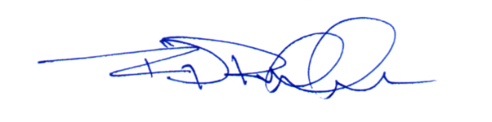  02-16-2024 | IACME Reference: |  | A9a
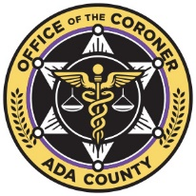

POLICY:
Participation in public education, outreach, information programs, and educational events, are encouraged for all personnel. When requested by schools, clubs, state and/or local emergency response agencies; personnel may perform and/or participate in educational activities as a representative of the Ada County Coroner’s Office (ACCO), pending authorization from the Coroner, or their designee.

PROCEDURE:
Staff members participating in educational events will adhere to the following:
- Any and all images of and from the ACCO (i.e., logos, archived photographs), are the property of the ACCO.
- At no time are images from open, current and/or homicide cases to be used.
- All images will be preapproved by a direct supervisor, with decedent and/or employee identifiers redacted.
- All training materials created by an employee during working hours are the property of the ACCO.

