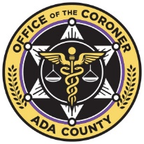 | Title: | RECORDS RETENTION |  | Policy # |  | RR.1.01
 | Division: | Administration |  | Page: |  | Page 1 of 2
Coroner Signature: |  |  | NAME Reference: |  | F1a,F1c,F1d,F1e,F1m,F1n, F1p,F1q,F1r,F1s,F6l,F6m
Approved/Revised Date: |  | 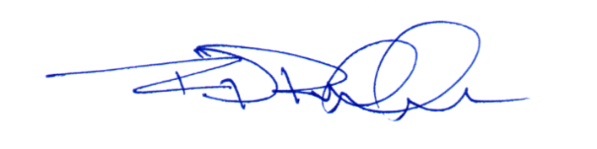  v08-26-2024 | IACME Reference: |  | A4g,A6a,A6b,A6n,A6o,A6p, B4i,B4j

POLICY:
To ensure that official records are retained in accordance with the requirements set forth by applicable Idaho State laws. All records, regardless of medium, shall be protected, secured, and stored in a manner that allows for timely retrieval. Digital records shall be permanently retained, while non-digital records shall be kept for a minimum of three (3) years.
The coroner is the official custodian of all Coroner Office records. These records shall transfer to any newly elected Coroner and administration as appropriate.
All case files, investigation reports, autopsy reports, policies, accreditation documentation records, and organizational operating procedures will be retained and preserved in toto. The aforementioned documents shall be made available to incoming administration during the administration transition period.

PROCEDURE:
All records, regardless of medium, will be electronically saved, backed up within the case management system, and secured in an appropriate, and maintained location.
- Active Files
  - Electronic files will be stored in the case management system.
  - Hard files will be secured in the casefile room at the Ada County Coroner’s Office (ACCO). Access to the casefile room is limited to administrative personnel via keycard control.
- Inactive Files
  - Electronic files will be closed upon case completion.
    - Reports and photos will be backed up in the case management system, and/or moved to an external storage device for permanent retention.
  - Hard files will be tagged, boxed, and stored in the casefile room for a minimum of three (3) years.
  - After the three (3) year minimum, the files will be digitized, backed up, and stored in the Ada County electronic filing system.
    - All ACCO electronic files are electronically accessible.
- Case Photos
  - Photos taken by ACCO personnel shall be uploaded immediately into the case management system and may be backed up using cloud computing software/external drives.
  - Photos and videos received from outside agencies shall be saved to an external drive and uploaded into the case management system when possible.
- Dictation Recordings
  - Recordings made for the purpose of dictation are not retained.
- New Administration
  - Upon verification of a transition to new administration, all operational records and reports shall be preserved. No documentation will be electronically deleted or destroyed.
  - Documentation and records will be provided to the new administration during the administration transition period.
  - The out-going Coroner/Chief Medicolegal Officer, Chief Deputy Coroner, or Chief Administrative Officer shall orient the in-coming administration on all documentation, records, and procedures.
  - Any record deletion and/or destruction shall be considered theft of Ada County property.

