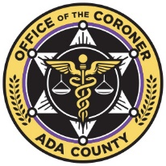 | Title: | ORGAN TISSUE DONATION |  | Policy # |  | G.5.01
 | Division: | Investigation, Pathology |  | Page: |  | Page 1 of 2
Coroner Signature: |  | 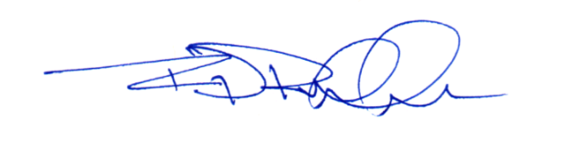 | NAME Reference: |  | A6a,B2b
Approved/Revised Date: |  | 02-20-2024 | IACME Reference: |  | A10a,A10b

POLICY:
The Ada County Coroner’s Office will actively participate in the implementation of the Uniform Anatomical Gift Act by authorizing, when practicable, the removal of organs and tissue in accordance with existing law and accepted medical practice. The ACCO will take every reasonable step to ensure that organ and tissue activities do not compromise the main mission of determining cause and manner of death, the interpretation of wounds, or the collection of evidence.
When a family makes a donation request, following the death of their loved one, the Ada County Coroner’s Office will work collaboratively with hospital staff, the organ/tissue procurement agencies, and the family. Without a formal request from the decedent, the next of kin, or a designated health care representative, anatomical gift donations shall not be approved.

PROCEDURE:
All decisions shall be completed as quickly as possible, so as to not delay the donation process.
- Deaths Under the Jurisdiction of the ACCO
  - The donation request, along with the circumstances surrounding the death and all medical records of significance, shall be reviewed by the Investigator and a forensic pathologist at the earliest opportunity.
  - Hospital admission blood shall be placed on hold and obtained as available Investigative Division staff allows.
  - The forensic pathologist may choose to approve, deny, or restrict, for donation/procurement, any and/or all organs or tissues based upon the medicolegal requirements of the death investigation.
    - Approved requests:
      - Pre-Examination Recovery
        - The forensic pathologist may request further study and documentation be completed.
        - The Coroner/Chief Deputy Coroner/ forensic pathologist may request an ACCO staff member to accompany the recovery team into the Operating Room.
        - Any requested and/or obtained specimens, including blood and/or vitreous humor, shall be collected and transported to the ACCO by the donation/procurement agency.
      - Post-Examination Recovery
        - Forensic staff, at the request of the donation/procurement agency, and at the direction of the forensic pathologist, may collect requested specimens during the postmortem examination in order to assist with the donation/procurement process.
        - Forensic staff, at the direction of the forensic pathologist, may be asked to avoid collecting specific specimens to allow for potential tissue donation/procurement consideration.
        - Signed release documentation shall be added to the ACCO case management system prior to release of the decedent for donation.
    - Denied or Restricted requests:
      - When the procurement of organs is either denied or restricted by the forensic pathologist, the Investigator shall:
        - Communicate the information to the organ/tissue procurement agency.
        - Document the denial or restriction in the ACCO case administration system.
- Deaths Not Under the Jurisdiction of the ACCO
  - The Investigator shall communicate with the donation/procurement agency that the death falls outside the jurisdiction of the ACCO.
  - The Investigator shall follow standard ACCO protocol for non-jurisdictional release death.

