 | Title: | RECEIVING AND RELEASE |  | Policy # |  | MO.1.04
 | Division: | Forensic, Investigation |  | Page: |  | Page 1 of 2
Coroner Signature: |  |  | NAME Reference: |  | B4j,C1a,C1j
Approved/Revised Date: |  | 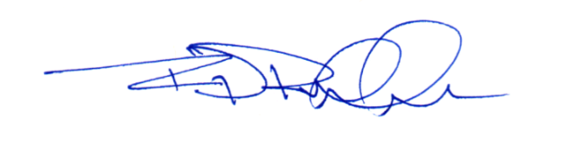  02-20-2024 | IACME Reference: |  | B2j,C2a,C5h


POLICY:
To ensure receipt into the Ada County Coroner facility is secure, well documented and follows established standard operating procedures, and best practice guidelines for decedents transported to the Ada County Coroner’s Office (ACCO).
The ACCO is committed to providing an efficient and timely release of decedents to authorized, licensed funeral home representatives following receipt of a written authorization from legal next-of-kin, or person authorized by law to receive the remains.

PROCEDURE:
- Receiving
  - Upon receipt at the ACCO facility, a member of either the Forensic or Investigation Division shall:
    - Confirm decedent is secured in a clean body bag.
    - Document the weight and identification of the decedent.
    - Follow ACCO standard operating procedure for proper chain of custody.
    - Secure the decedent in a refrigerated cooler.
- Release
  - Measures will be taken to ensure the identification, documentation, preparation, and holding of decedents, and any personal effects, prior to an authorized release.
  - Upon release, decedent identification shall be confirmed by both releasing and receiving parties through visual confirmation of identification band secured to decedent.
  - A chain of custody form shall be completed and signed, by both receiving and releasing parties, and included within the ACCO case management system.
  - Any remaining property not released to the investigating law enforcement agency, shall accompany the decedent and be released to a representative from the licensed funeral home; or person permitted to transport remains.
  - As approved by ACCO administration, personal effects may be released separately to the legal next of kin/personal representative prior to the release of the decedent, following standard operating procedure.
- Unidentified Remains
  - Use of radiographs, photographs, fingerprints, DNA, dentition charts, and other means, shall be exhausted in an attempt to obtain positive identification, and shall be retained indefinitely.
  - All photographs, radiographs, autopsy reports, descriptions, and other materials required to make identification at a future date will remain on file.
  - Final disposition shall follow ACCO Policy: Identification.

